*Architectures. We consider the following architectures: VGG-16, DenseNet-161, ResNet-18, ResNet-50, ResNet-152 and GoogLeNet*

Parameter number rank:

VGG16 > RenNet-152 > DenseNet-161 ~= RenNet-50 > GoogLeNet > RenNet-18

ImageNet-1k performance for various architectures,

ref: Benchmark Analysis of Representative Deep Neural Network Architectures

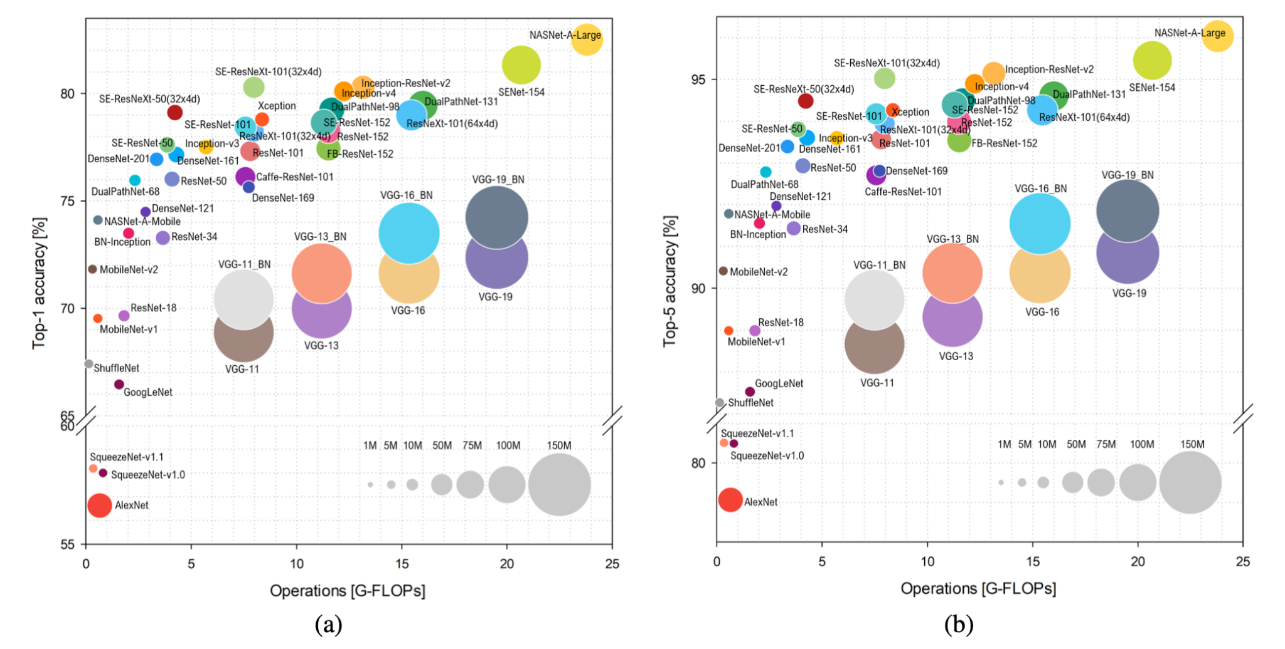

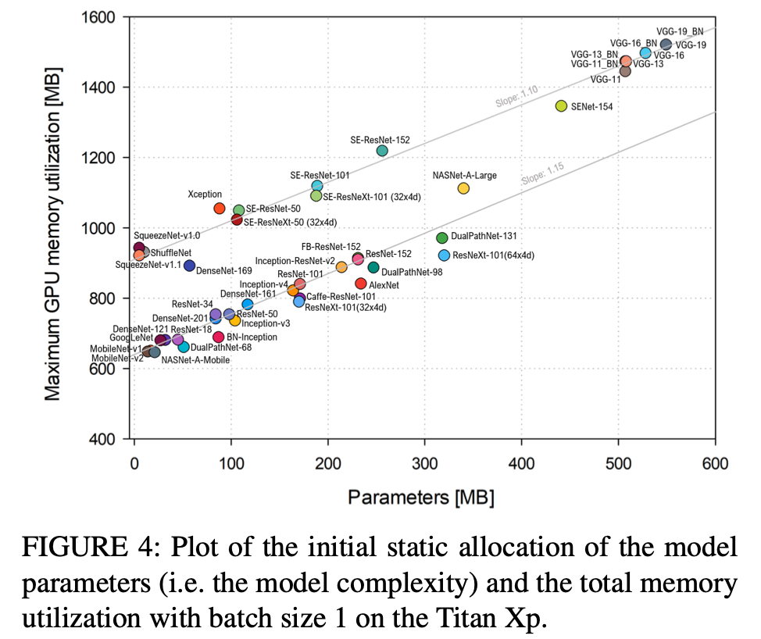

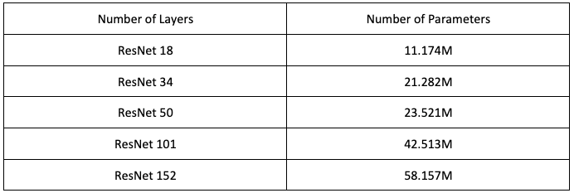

| Arch | # parameters | FLOPs | File Size |
| --- | --- | --- | --- |
|  |  |  |  |
|  |  |  |  |
| ResNet-18 | 1 M | 1.8 b |  |
| ResNet-50 | 23 M | 3.8b |  |
| ResNet-152 | 58 M | 11.3b |  |
| GoogLeNet | 11M | 1.5b |  |
| DenseNet-161 | 29 Million | 8 Billion | 110.37 MB (Pytorch) |
| VGG-16 | 138 million | 15.3 billion FLOPs |  |
|  |  |  |  |

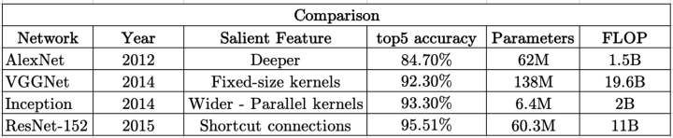

Ref: <https://towardsdatascience.com/the-w3h-of-alexnet-vggnet-resnet-and-inception-7baaaecccc96>

